**SPRINT DELIVERY PLAN INTRODUCTION:**

Sprint planning is an event in scrum that kicks off the sprint. The purpose of sprint planning is to define what can be delivered in the sprint and how that work will be achieved. Sprint planning is done in collaboration with the whole scrum team. In scrum, the sprint is a set period of time where all the work is done. However, before you can leap into action you have to set up the sprint. You need to decide on how long the time box is going to be, the sprint goal, and where you're going to start. The sprint planning session kicks off the sprint by setting the agenda and focus. If done correctly, it also creates an environment where the team is motivated, challenged, and can be successful. Bad sprint plans can derail the team by setting unrealistic expectations.

**The Inputs** – A great starting point for the sprint plan is the product backlog as it provides a list of ‘stuff’ that could potentially be part of the current sprint.

**The Outputs** – The most important outcome for the sprint planning meeting is that the team can describe the goal of the sprint and how it will start working toward that goal.

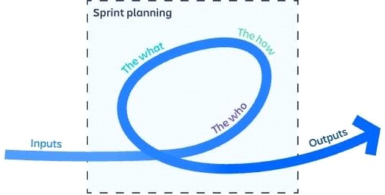

**SETTING A TIME LIMIT FOR SPRINT PLANNING**

Sprint planning should be constrained no more than two hours for each week of the sprint. So, for example, the sprint planning meeting for a two-week sprint would be no longer than four hours. This is called "time boxing", or setting a maximum amount of time for the team to accomplish a task, in this case, planning the sprint. The scrum master is responsible for making sure the meeting happens the time box is understood. If the team is happy before the timebox is finished, then the event is over. A time box is a maximum time allowed; there is no minimum time allowed.

**FOCUS ON THE OUTCOMES, NOT THE WORK :**

During sprint planning it is easy to get ‘bogged down’ in the work focusing on which task should come first, who should do it, and how long will it take. For complex work, the level of information you know at the start can be low, and much of it is based on assumptions. Scrum is an empirical process, meaning that you can’t plan upfront, but rather learn by doing, and then feed that information back into the process.

The goal of User stories are one great way of describing the work from a customer point of view. User stories, written like the one below, re-focus defects, issues, and improvements on the outcome the customer is seeking rather than the observed problem.

As<type of user>,I want<a goal>so that<a reason>

By adding clear, measurable results to the user story, the outcomes can be clearly measured, and you know when you are done. For example, leaving things vague is much worse than describing something as a question to be answered during the sprint.

# **ESTIMATES ARE REQUIRED BUT DON'T PRETEND YOU KNOW MORE THAN YOU DO :**

Sprint planning requires some level of estimation. The team needs to define what can

or cannot be done in the sprint: estimated effort vs capacity. Estimation is often confused with commitments. Estimates are by their nature forecasts based on the knowledge at hand. Techniques such as story points or t-shirt sizing add value to the process by giving the team a different way of looking at the problem. They are not, however, magical tools that can find out the truth when there is none to be found. The more unknowns, the less likely the estimate will be correct.

Good estimation requires a trust-based environment where information is given freely, and assumptions are discussed in the pursuit of learning and improvement. If estimates are used in a negative, confrontational way after the work is completed, then it’s likely that future estimates will be either be much bigger to ensure they never are wrong again or the time taken to create them will be much longer as the team second guesses itself worrying about the implications of getting them wrong.



# **SPRINT PLANNING BEST PRACTICE :**

It is easy to get so bogged down in the details of sprint planning you forget that the focus of sprint planning is to build a ‘just enough’ plan for the next sprint. That plan shouldn’t become a monkey for the team’s back, instead, it should focus the team on valuable outcomes, and allow guardrails for self-organization. A good sprint plan motivates everyone by defining an outcome and a clear plan for success. the most complete, “every minute of the sprint is accounted for” sprint plan, focus on the goal and build enough of a sprint backlog to get started.

Scrum is a process framework aimed at solving complex problems.

Complex problems require an empirical process (learning by doing). Empirical processes are very hard to plan, so don’t kid yourself--you can’t build the perfect plan.

# **5 STEPS TO MASTER SPRINT PLANNING :**

**Step1: Review your product roadmap**

The goal of an agile sprint is to ship better software. But that’s easier said than done. It’s easy to lose sight of the bigger picture when you’re knee-deep in code fixes and update Are you building features that move your product vision forward? Do you even have a product vision or are you just reacting to loud customers? The first step in sprint planning is to know where you want to be not just at the end of this sprint but in 6 months, a year, or more. As scrum master and agile coach Robbi Schur man writes:

“There are always too many features that would add value, therefore creating a lack of focus on the vision and goals. By focusing on the features too much, the roadmap will turn into an overloaded product backlog, instead of a high-level, strategic plan for the products' future development.”

**Step 2: Groom your product backlog and update user stories**

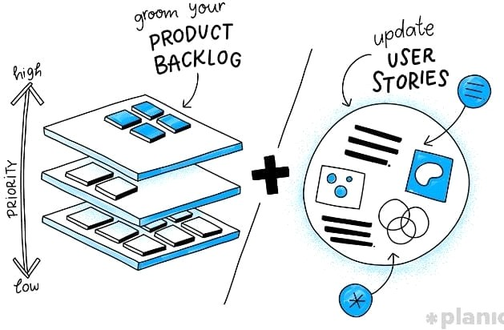

With your mind primed with your product vision, it’s time to dive into your backlog and start pulling out user stories to tackle in the next two sprints. Your product backlog is all of the bugs, issues, and user stories (informal, natural language descriptions of one or more desired features, often written from the perspective of your actual users). A 30-minute product backlog grooming sessions helps fill in the blacks on user stories that are lacking detail or context from you, the product owner. This means making sure each story:

* Is prioritized with the most important work listed at the top.
* Is clear and fully-formed so the team can start working on right away.
* Is up-to-date in context (to the larger product roadmap) and estimate (of complexity).

# **Step 3: Propose a sprint goal and backlog before the sprint planning meeting**

The what is your Sprint goal: Simply put, what you want to have delivered by the end of the sprint. Sprint goals are a great “why” for your team keeping them motivated. But they’re also great for communicating what’s being worked on to people outside of your team. For example, if you’re running an ecommerce site, it might be something like: “Develop the checkout process: Pay, choose shipping, include discounts.”

# Next, the how is your Sprint backlog: the list of user stories that will need to be completed in order to achieve your sprint goal. It’s entirely possible that you’ll have separate sprint planning meetings to go over your goal and your backlog. However, whether you do it all at once or on separate days, it’s important that your team has time to look over what you’re proposing beforehand so they can form a good understanding of what needs to be done and what tasks are most important.

# **Step 4: Use data and experience to supercharge your Sprint planning meeting**

The Scrum Guide suggests time boxing your sprint planning meeting to just 8-hours for a month-long sprint (not all at once, of course). For shorter sprints, your meetings should be adjusted accordingly. Your scrum master is responsible for making sure these meetings happen and stick to their agenda.

Product owner: Sets the goals, priorities, and explains context around the choices for this sprint. They’ve ensured backlog items are properly groomed and also that the team’s skills, capabilities, and resources are aligned with the needs of the sprint.

Scrum master: Facilitates the meeting by preparing and sharing the agenda, setting up the location, and making sure everyone’s there. For remote development teams, this means having video conferencing software like Zoom ready and tested.

Agile team members: Ask questions and propose concerns about the sprint backlog. The development team can also bring in outsiders with domain or technical advice to help plan.

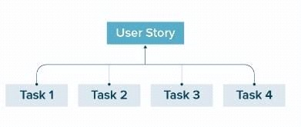

**Revisit your definition of “done”:** This is the snapshot of what your software will look like at the end of the sprint. It’s important that the people doing the work (the developers) and those inspecting it (the product owner/other stakeholders) are both on the same page here.

**Clarify the acceptance criteria:** Just like you need to know what “done” looks like on a sprint-level. You need to know what is acceptable on a task-level to call it complete. This is usually up to the product owner to decide, however, it’s good to have a conversation around it as a team.

**Development team agrees on their capacity for the sprint**: While the product owner can help clarify the selected items in this sprint, an important part of Agile development is that it’s the responsibility of the development team to decide what can get done in a sprint. The development team agrees on their capacity and designs a system of how they’re going to get the work done—self-organizing and breaking the work planned for the first day down into small units.

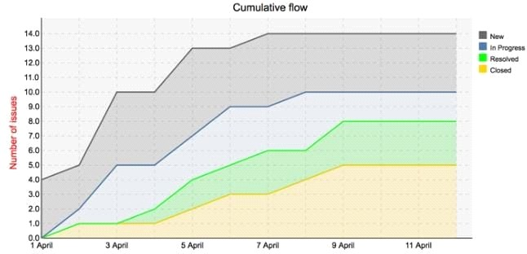

# **Step 5: Walk through each user story and describe what tasks need to be done**

# 

There’s a desire to rush through this next part of the exercise and just get to it. But the more detailed planning you can do as a team, the less likely you’re going to hit roadblocks a week or two into your sprint.

**Ready, set, sprint!**

As French writer and pioneering aviator, Antoine de Saint-Exupéry, famously wrote:

“A goal without a plan is just a wish.”

Proper sprint planning does a lot of things well. But most of all, it turns your goals from a wish into a step-by-step guide. If you’ve followed this guide, at the end of your sprint planning session you and your entire team should walk away with:

An agreed-upon Sprint Goal and a clear definition of done Commitment to a realistic sprint backlog.

* Understanding of the bug fixes and support work included in the backlog
* Detailed tasks for each user story with an estimation and acceptance criteria.
* Due dates and scheduled scrum meetings

# **CONCLUSION** :

The complete guide to running a successful sprint delivery planning based on the what he team has prioritized to deliver to the end user soon.

.